|  |  |
| --- | --- |
| **Intelligent Systems** | |
| **Project 1** | |
| **Name** | Student Id |
| **Nilanjan Mhatre** | 801045013 |
| **Akash** | 801043608 |

**8-puzzle Formulation**

The 8-puzzle is solved by using heuristic function and generating a tree by expanding the nodes having the least heuristic.

Manhattan distance or Misplaced tiles count can be used as a heuristic.

The A* algorithm aims at using the heuristic as well as the distance travelled so far, combined to make a selection of the nodes from the fringe.

**Program Structure**

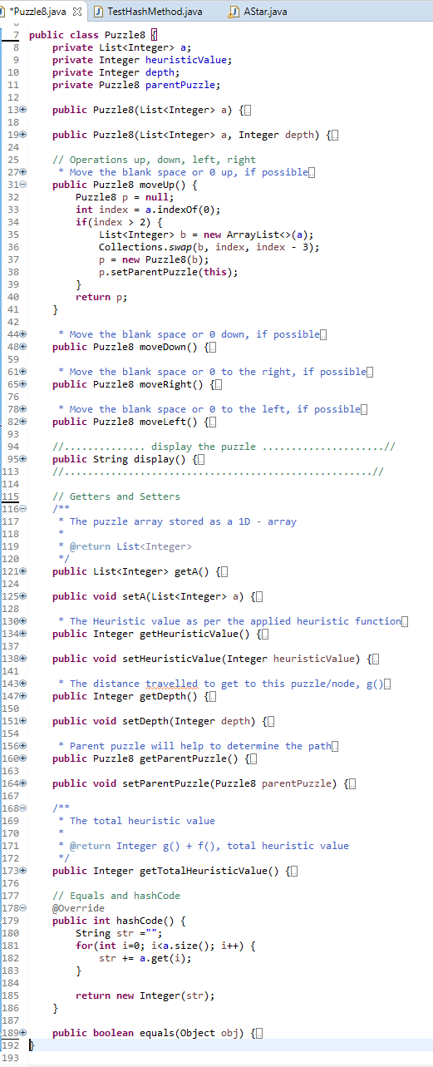

1. An **instance** of class ‘Puzzle8’ stores a particular **state**, along with its heuristic value (h), the distance/depth travelled (g) to get to that state and the parent ‘Puzzle8’.
2. The array ‘a’ defines the number arrangement as a 1D array.

e.g. a= {1, 2, 3, 4, 5, 6, 7, 8, 0}

implies $\left[\begin{aligned}1 2 3 \\ 4 5 6 \\ 7 8-\end{aligned}\right]$

1. ‘**hashCode’** method returns ‘**hash**’ of every state, which would be unique for each state of all 9! i.e. 362880 combinations possible (Checked using **TestHashMethod.java**). This value will be used to store states that were already **visited** in the A-star algorithm, rather than storing the whole ‘Puzzle8’ object or the array
2. ‘equals’ method uses ‘hashCode’ rather than comparing for every array element
3. **Operations** include moving blank space - **up**, **down**, **right** or **left**. The operation will return a new instance of ‘Puzzle8’, which would have the parent as the current instance
4. Correct logic is applied for each of the operations while dealing with a 1D representation
5. E.g. Up operation swaps the ‘blank’ at (position) with element at (position – 3)
6. If the operation is not possible, null is returned

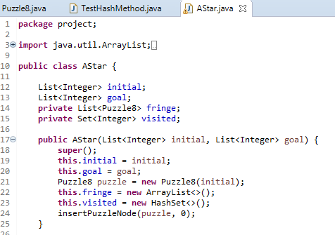

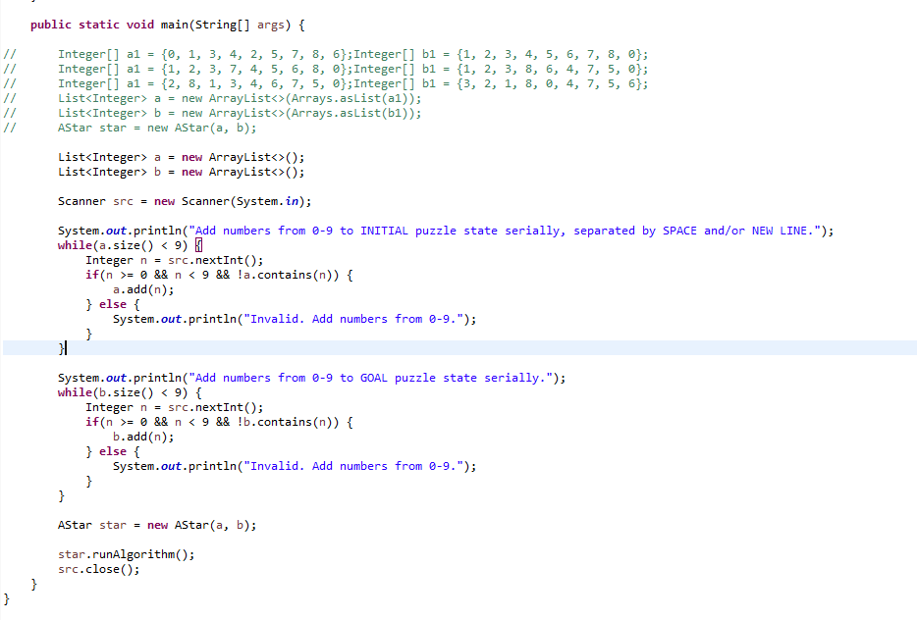

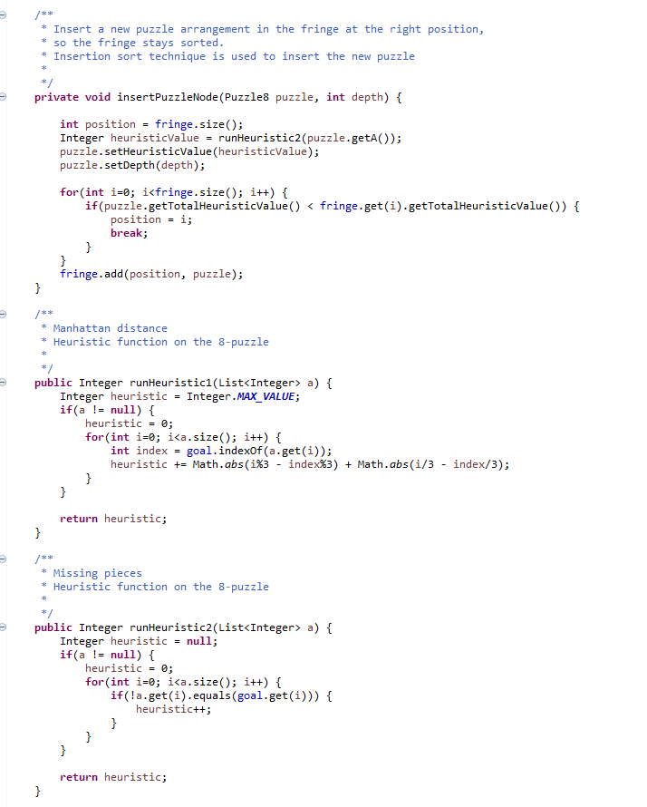

1. ‘Astar’ class instance will take the **initial** and the **goal** state
2. A ‘**fringe’** of puzzles will be created, that will include the initial state already present
3. Again, the states are 1D arrays, represented for the 8-puzzle problem, to improve performance by keeping minimal references
4. User input will be taken as initial and goal state
5. ‘**insertPuzzleNode**’ inserts every expanded node/state to the fringe
6. ‘**Insertion sort**’ technique is used to determine the right position to insert the new puzzle based on

‘totalHeuristic=(g)+(h)’

1. Two heuristic functions are defined, that are called in ‘insertPuzzleNode’
2. ‘runHeuristic1’ is **Manhattan distance**

“Formula for 1D array =

abs|index%3 - correctIndex%3| +

abs|index/3 - correctIndex/3|”

1. ‘runHeuristic2’ is **Misplaced tiles**

Formula for 1D array

=(counter++) for every mismatched index

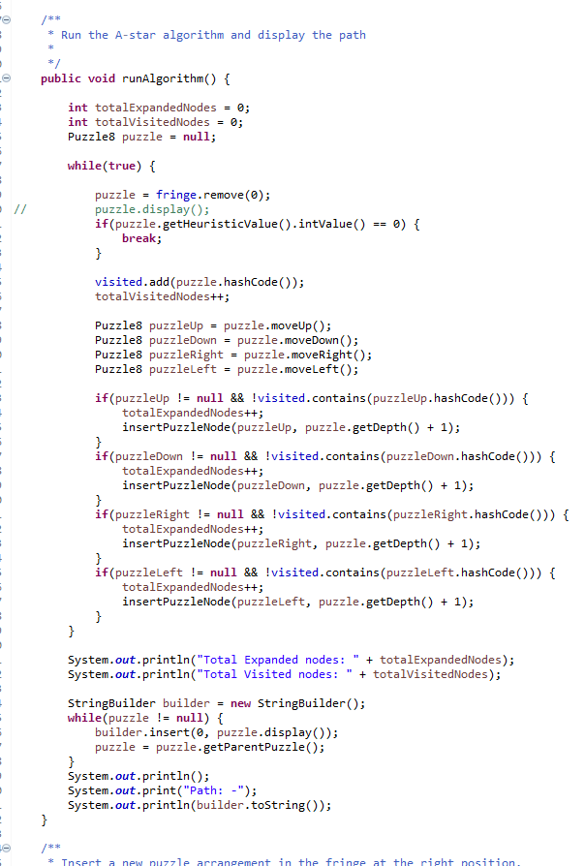

Algorithm: -

1. The loop breaks when the ‘**heuristic value**’ equals 0
2. The ‘**fringe**’ is always sorted as the sorting is carried while inserting
3. Hence, the least heuristic node/puzzle is at the 0th index
4. Add its ‘hashCode’ to the ‘**visited**’ list and increment ‘totalVisited’ counter
5. If it is not the goal, **expand** to generate more nodes by performing operations – **up**, **down**, **right**, **left**, whichever is possible, and add the generated nodes/puzzles to the fringe by insert operation maintaining the sorting
6. Increment the ‘totalExpanded’ counter
7. When the loop breaks, the ‘puzzle’ object will contain the goal state
8. **Trace** **the complete path by ‘parentPuzzle’ link**

**Sample results for Misplaced Tile Heuristics**

Add numbers from 0-9 to INITIAL puzzle state serially, separated by SPACE and/or NEW LINE.

0 1 3 4 2 5 7 8 6

Add numbers from 0-9 to GOAL puzzle state serially.

1 2 3 4 5 6 7 8 0

Total Expanded nodes: 9

Total Visited nodes: 4

Path: -

_ 1 3

4 2 5

7 8 6

1 _ 3

4 2 5

7 8 6

1 2 3

4 _ 5

7 8 6

1 2 3

4 5 _

7 8 6

1 2 3

4 5 6

7 8 _

Process finished with exit code 0

********************************************************

Add numbers from 0-9 to INITIAL puzzle state serially, separated by SPACE and/or NEW LINE.

1 2 3 7 4 5 6 8 0

Add numbers from 0-9 to GOAL puzzle state serially.

1 2 3 8 6 4 7 5 0

Total Expanded nodes: 43

Total Visited nodes: 23

Path: -

1 2 3

7 4 5

6 8 _

1 2 3

7 4 _

6 8 5

1 2 3

7 _ 4

6 8 5

1 2 3

7 8 4

6 _ 5

1 2 3

7 8 4

_ 6 5

1 2 3

_ 8 4

7 6 5

1 2 3

8 _ 4

7 6 5

1 2 3

8 6 4

7 _ 5

1 2 3

8 6 4

7 5 _

Process finished with exit code 0

********************************************************

Add numbers from 0-9 to INITIAL puzzle state serially, separated by SPACE and/or NEW LINE.

2 8 1 3 4 6 7 5 0

Add numbers from 0-9 to GOAL puzzle state serially.

3 2 1 8 0 4 7 5 6

Total Expanded nodes: 14

Total Visited nodes: 7

Path: -

2 8 1

3 4 6

7 5 _

2 8 1

3 4 _

7 5 6

2 8 1

3 _ 4

7 5 6

2 _ 1

3 8 4

7 5 6

_ 2 1

3 8 4

7 5 6

3 2 1

_ 8 4

7 5 6

3 2 1

8 _ 4

7 5 6

Process finished with exit code 0

********************************************************

Add numbers from 0-9 to INITIAL puzzle state serially, separated by SPACE and/or NEW LINE.

2 8 3 1 6 4 7 0 5

Add numbers from 0-9 to GOAL puzzle state serially.

1 2 3 8 0 4 7 6 5

Total Expanded nodes: 13

Total Visited nodes: 6

Path: -

2 8 3

1 6 4

7 _ 5

2 8 3

1 _ 4

7 6 5

2 _ 3

1 8 4

7 6 5

_ 2 3

1 8 4

7 6 5

1 2 3

_ 8 4

7 6 5

1 2 3

8 _ 4

7 6 5

Process finished with exit code 0

********************************************************

Add numbers from 0-9 to INITIAL puzzle state serially, separated by SPACE and/or NEW LINE.

8 1 3 4 0 2 7 6 5

Add numbers from 0-9 to GOAL puzzle state serially.

1 2 3 4 5 6 7 8 0

Total Expanded nodes: 555

Total Visited nodes: 338

Path: -

8 1 3

4 _ 2

7 6 5

8 1 3

4 2 _

7 6 5

8 1 3

4 2 5

7 6 _

8 1 3

4 2 5

7 _ 6

8 1 3

4 2 5

_ 7 6

8 1 3

_ 2 5

4 7 6

_ 1 3

8 2 5

4 7 6

1 _ 3

8 2 5

4 7 6

1 2 3

8 _ 5

4 7 6

1 2 3

_ 8 5

4 7 6

1 2 3

4 8 5

_ 7 6

1 2 3

4 8 5

7 _ 6

1 2 3

4 _ 5

7 8 6

1 2 3

4 5 _

7 8 6

1 2 3

4 5 6

7 8 _

Process finished with exit code 0

********************************************************

Add numbers from 0-9 to INITIAL puzzle state serially, separated by SPACE and/or NEW LINE.

7 2 4 5 0 6 8 3 1

Add numbers from 0-9 to GOAL puzzle state serially.

1 2 3 4 5 6 7 8 0

Total Expanded nodes: 6790

Total Visited nodes: 4286

Path: -

7 2 4

5 _ 6

8 3 1

7 2 4

5 3 6

8 _ 1

7 2 4

5 3 6

8 1 _

7 2 4

5 3 _

8 1 6

7 2 4

5 _ 3

8 1 6

7 2 4

_ 5 3

8 1 6

_ 2 4

7 5 3

8 1 6

2 _ 4

7 5 3

8 1 6

2 4 _

7 5 3

8 1 6

2 4 3

7 5 _

8 1 6

2 4 3

7 _ 5

8 1 6

2 4 3

7 1 5

8 _ 6

2 4 3

7 1 5

_ 8 6

2 4 3

_ 1 5

7 8 6

2 4 3

1 _ 5

7 8 6

2 _ 3

1 4 5

7 8 6

_ 2 3

1 4 5

7 8 6

1 2 3

_ 4 5

7 8 6

1 2 3

4 _ 5

7 8 6

1 2 3

4 5 _

7 8 6

1 2 3

4 5 6

7 8 _

Process finished with exit code 0

********************************************************

Add numbers from 0-9 to INITIAL puzzle state serially, separated by SPACE and/or NEW LINE.

1 2 0 4 5 3 7 8 6

Add numbers from 0-9 to GOAL puzzle state serially.

1 2 3 4 5 6 7 8 0

Total Expanded nodes: 4

Total Visited nodes: 2

Path: -

1 2 _

4 5 3

7 8 6

1 2 3

4 5 _

7 8 6

1 2 3

4 5 6

7 8 _

Process finished with exit code 0

********************************************************

Add numbers from 0-9 to INITIAL puzzle state serially, separated by SPACE and/or NEW LINE.

1 2 3 0 4 6 7 5 8

Add numbers from 0-9 to GOAL puzzle state serially.

1 2 3 4 5 6 7 8 0

Total Expanded nodes: 8

Total Visited nodes: 3

Path: -

1 2 3

_ 4 6

7 5 8

1 2 3

4 _ 6

7 5 8

1 2 3

4 5 6

7 _ 8

1 2 3

4 5 6

7 8 _

Process finished with exit code 0

********************************************************

Add numbers from 0-9 to INITIAL puzzle state serially, separated by SPACE and/or NEW LINE.

3 8 2 4 5 6 1 7 0

Add numbers from 0-9 to GOAL puzzle state serially.

1 2 3 4 5 6 7 8 0

Total Expanded nodes: 14780

Total Visited nodes: 9385

Path: -

3 8 2

4 5 6

1 7 _

3 8 2

4 5 _

1 7 6

3 8 2

4 _ 5

1 7 6

3 8 2

_ 4 5

1 7 6

3 8 2

1 4 5

_ 7 6

3 8 2

1 4 5

7 _ 6

3 8 2

1 4 5

7 6 _

3 8 2

1 4 _

7 6 5

3 8 _

1 4 2

7 6 5

3 _ 8

1 4 2

7 6 5

_ 3 8

1 4 2

7 6 5

1 3 8

_ 4 2

7 6 5

1 3 8

4 _ 2

7 6 5

1 3 8

4 2 _

7 6 5

1 3 _

4 2 8

7 6 5

1 _ 3

4 2 8

7 6 5

1 2 3

4 _ 8

7 6 5

1 2 3

4 6 8

7 _ 5

1 2 3

4 6 8

7 5 _

1 2 3

4 6 _

7 5 8

1 2 3

4 _ 6

7 5 8

1 2 3

4 5 6

7 _ 8

1 2 3

4 5 6

7 8 _

Process finished with exit code 0

********************************************************

**Sample Solution for Manhattan distance heuristics**

Add numbers from 0-9 to INITIAL puzzle state serially, separated by SPACE and/or NEW LINE.

0 1 3

4 2 5

7 8 6

Add numbers from 0-9 to GOAL puzzle state serially.

1 2 3

4 5 6

7 8 0

Total Expanded nodes: 9

Total Visited nodes: 4

Path: -

_ 1 3

4 2 5

7 8 6

1 _ 3

4 2 5

7 8 6

1 2 3

4 _ 5

7 8 6

1 2 3

4 5 _

7 8 6

1 2 3

4 5 6

7 8 _

Process finished with exit code 0

********************************************************

Add numbers from 0-9 to INITIAL puzzle state serially, separated by SPACE and/or NEW LINE.

1 2 3

7 4 5

6 8 0

Add numbers from 0-9 to GOAL puzzle state serially.

1 2 3 8 6

4 7 5 0

Total Expanded nodes: 22

Total Visited nodes: 11

Path: -

1 2 3

7 4 5

6 8 _

1 2 3

7 4 _

6 8 5

1 2 3

7 _ 4

6 8 5

1 2 3

7 8 4

6 _ 5

1 2 3

7 8 4

_ 6 5

1 2 3

_ 8 4

7 6 5

1 2 3

8 _ 4

7 6 5

1 2 3

8 6 4

7 _ 5

1 2 3

8 6 4

7 5 _

Process finished with exit code 0

********************************************************

Add numbers from 0-9 to INITIAL puzzle state serially, separated by SPACE and/or NEW LINE.

2 8 1 3 4 6 7 5 0

Add numbers from 0-9 to GOAL puzzle state serially.

3 2 1 8 0 4 7 5 6

Total Expanded nodes: 12

Total Visited nodes: 6

Path: -

2 8 1

3 4 6

7 5 _

2 8 1

3 4 _

7 5 6

2 8 1

3 _ 4

7 5 6

2 _ 1

3 8 4

7 5 6

_ 2 1

3 8 4

7 5 6

3 2 1

_ 8 4

7 5 6

3 2 1

8 _ 4

7 5 6

Process finished with exit code 0

********************************************************

Add numbers from 0-9 to INITIAL puzzle state serially, separated by SPACE and/or NEW LINE.

8 1 3 4 0 2 7 6 5

Add numbers from 0-9 to GOAL puzzle state serially.

1 2 3 4 5 6 7 8 0

Total Expanded nodes: 187

Total Visited nodes: 110

Path: -

8 1 3

4 _ 2

7 6 5

8 1 3

4 2 _

7 6 5

8 1 3

4 2 5

7 6 _

8 1 3

4 2 5

7 _ 6

8 1 3

4 2 5

_ 7 6

8 1 3

_ 2 5

4 7 6

_ 1 3

8 2 5

4 7 6

1 _ 3

8 2 5

4 7 6

1 2 3

8 _ 5

4 7 6

1 2 3

_ 8 5

4 7 6

1 2 3

4 8 5

_ 7 6

1 2 3

4 8 5

7 _ 6

1 2 3

4 _ 5

7 8 6

1 2 3

4 5 _

7 8 6

1 2 3

4 5 6

7 8 _

Process finished with exit code 0

********************************************************

Add numbers from 0-9 to INITIAL puzzle state serially, separated by SPACE and/or NEW LINE.

2 8 3 1 6 4 7 0 5

Add numbers from 0-9 to GOAL puzzle state serially.

1 2 3 8 0 4 7 6 5

Total Expanded nodes: 11

Total Visited nodes: 5

Path: -

2 8 3

1 6 4

7 _ 5

2 8 3

1 _ 4

7 6 5

2 _ 3

1 8 4

7 6 5

_ 2 3

1 8 4

7 6 5

1 2 3

_ 8 4

7 6 5

1 2 3

8 _ 4

7 6 5

Process finished with exit code 0

********************************************************

Add numbers from 0-9 to INITIAL puzzle state serially, separated by SPACE and/or NEW LINE.

7 2 4 5 0 6 8 3 1

Add numbers from 0-9 to GOAL puzzle state serially.

1 2 3 4 5 6 7 8 0

Total Expanded nodes: 746

Total Visited nodes: 460

Path: -

7 2 4

5 _ 6

8 3 1

7 2 4

5 3 6

8 _ 1

7 2 4

5 3 6

8 1 _

7 2 4

5 3 _

8 1 6

7 2 4

5 _ 3

8 1 6

7 2 4

_ 5 3

8 1 6

_ 2 4

7 5 3

8 1 6

2 _ 4

7 5 3

8 1 6

2 4 _

7 5 3

8 1 6

2 4 3

7 5 _

8 1 6

2 4 3

7 _ 5

8 1 6

2 4 3

7 1 5

8 _ 6

2 4 3

7 1 5

_ 8 6

2 4 3

_ 1 5

7 8 6

2 4 3

1 _ 5

7 8 6

2 _ 3

1 4 5

7 8 6

_ 2 3

1 4 5

7 8 6

1 2 3

_ 4 5

7 8 6

1 2 3

4 _ 5

7 8 6

1 2 3

4 5 _

7 8 6

1 2 3

4 5 6

7 8 _

Process finished with exit code 0

********************************************************

Add numbers from 0-9 to INITIAL puzzle state serially, separated by SPACE and/or NEW LINE.

1 2 0 4 5 3 7 8 6

Add numbers from 0-9 to GOAL puzzle state serially.

1 2 3 4 5 6 7 8 0

Total Expanded nodes: 4

Total Visited nodes: 2

Path: -

1 2 _

4 5 3

7 8 6

1 2 3

4 5 _

7 8 6

1 2 3

4 5 6

7 8 _

Process finished with exit code 0

********************************************************

Add numbers from 0-9 to INITIAL puzzle state serially, separated by SPACE and/or NEW LINE.

1 2 3 0 4 6 7 5 8

Add numbers from 0-9 to GOAL puzzle state serially.

1 2 3 4 5 6 7 8 0

Total Expanded nodes: 8

Total Visited nodes: 3

Path: -

1 2 3

_ 4 6

7 5 8

1 2 3

4 _ 6

7 5 8

1 2 3

4 5 6

7 _ 8

1 2 3

4 5 6

7 8 _

Process finished with exit code 0

********************************************************

Add numbers from 0-9 to INITIAL puzzle state serially, separated by SPACE and/or NEW LINE.

3 8 2 4 5 6 1 7 0

Add numbers from 0-9 to GOAL puzzle state serially.

1 2 3 4 5 6 7 8 0

Total Expanded nodes: 2881

Total Visited nodes: 1789

Path: -

3 8 2

4 5 6

1 7 _

3 8 2

4 5 _

1 7 6

3 8 2

4 _ 5

1 7 6

3 8 2

_ 4 5

1 7 6

3 8 2

1 4 5

_ 7 6

3 8 2

1 4 5

7 _ 6

3 8 2

1 4 5

7 6 _

3 8 2

1 4 _

7 6 5

3 8 _

1 4 2

7 6 5

3 _ 8

1 4 2

7 6 5

_ 3 8

1 4 2

7 6 5

1 3 8

_ 4 2

7 6 5

1 3 8

4 _ 2

7 6 5

1 3 8

4 2 _

7 6 5

1 3 _

4 2 8

7 6 5

1 _ 3

4 2 8

7 6 5

1 2 3

4 _ 8

7 6 5

1 2 3

4 6 8

7 _ 5

1 2 3

4 6 8

7 5 _

1 2 3

4 6 _

7 5 8

1 2 3

4 _ 6

7 5 8

1 2 3

4 5 6

7 _ 8

1 2 3

4 5 6

7 8 _

Process finished with exit code 0